Gover2Me API Reference
Base URL: https://gover2me.ngrok.app

Authentication
Currently, no authentication is required. All routes respond with Access-Control-Allow-Origin: *.

Endpoints

1. Media Affinity vs Social Networks
GET /api/media-affinity_socialnets
Returns the "affinity vs reach" dispersion of media outlets. Supports exporting pre-calculated PNG.

Query Parameters
Parameter | Type | Default | Description
window | string | 30d | Time window. Options: 7d, 30d, 90d
format | string | json | Response format. Options: json, png

Response (200 - application/json)
{
"meta": {
"window": "30d",
"generated_at": "2025-10-16T14:30:00Z",
"units": {
"affinity": {
"min": 0,
"max": 100
},
"reach": {
"min": 0,
"max": 100
}
}
},
"points": [
{
"name": "Media Outlet A",
"url": "https://example.com/media-a",
"affinity": 75.5,
"reach": 82.3
},
{
"name": "Media Outlet B",
"url": "https://example.com/media-b",
"affinity": 45.2,
"reach": 91.7
}
],
"sources": [
["Source Name 1", "https://source1.com"],
["Source Name 2", "https://source2.com"]
]
}

Examples
# Get JSON data with 30-day window
curl -s "https://gover2me.ngrok.app/api/media-affinity_socialnets?window=30d" | jq

# Download PNG image
curl -o affinity.png "https://gover2me.ngrok.app/api/media-affinity_socialnets?window=30d&format=png"

2. Message Evaluation
GET /api/message-evaluation
Lists recent evaluations of political messages, ordered by score.

Query Parameters
Parameter | Type | Default | Description
min_score | integer | 0 | Minimum score (0-100)
limit | integer | 5 | Maximum number of results

Response (200 - application/json)
{
"meta": {
"generated_at": "2025-10-16T14:30:00Z",
"total": 25,
"score_range": {
"min": 0,
"max": 100
}
},
"evaluations": [
{
"id": "eval_123456",
"score": 85,
"text": "Comprehensive education reform proposal with clear implementation timeline"
},
{
"id": "eval_123457",
"score": 72,
"text": "Healthcare initiative addressing accessibility in rural areas"
},
{
"id": "eval_123458",
"score": 68,
"text": "Economic stimulus package targeting small businesses"
}
]
}

Example
curl -s "https://gover2me.ngrok.app/api/message-evaluation?min_score=50&limit=3" | jq

3. Social Monitoring
GET /api/social-monitoring
Exposes recent posts from political figures on social media, filterable by topic.

Query Parameters
Parameter | Type | Default | Description
topics | string | all topics | Comma-separated list. Valid values: vivienda, educacion, sanidad, economia, seguridad, transporte
limit | integer | 10 | Maximum number of results
since | ISO 8601 datetime | last 24h | Filter posts after this timestamp

Response (200 - application/json)
{
"meta": {
"generated_at": "2025-10-16T14:30:00Z",
"total": 45,
"platforms": ["twitter", "facebook", "instagram"]
},
"posts": [
{
"id": "post_789012",
"timestamp": "2025-10-16T12:15:00Z",
"text": "Announcing new housing initiatives to address affordability crisis in urban areas...",
"platform": "twitter",
"author": {
"name": "Political Figure A",
"handle": "@politicianA",
"verified": true,
"avatar": "https://example.com/avatars/politicianA.jpg"
},
"engagement": {
"views": 125000,
"likes": 4500,
"retweets": 890
}
},
{
"id": "post_789013",
"timestamp": "2025-10-16T10:30:00Z",
"text": "Education reform proposal focuses on teacher training and technology integration...",
"platform": "facebook",
"author": {
"name": "Political Figure B",
"handle": "politicianB",
"verified": true,
"avatar": "https://example.com/avatars/politicianB.jpg"
},
"engagement": {
"views": 89000,
"likes": 2100,
"retweets": null
}
}
]
}

Example
curl -s "https://gover2me.ngrok.app/api/social-monitoring?topics=vivienda,educacion&limit=5&since=2025-10-14T12:00:00Z" | jq

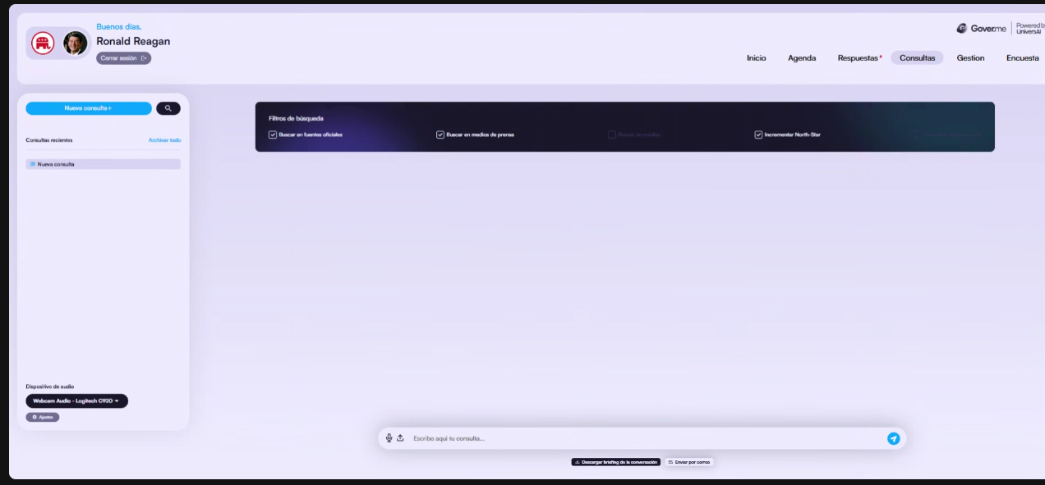
In the above image, replace:
1) Consultas → Medios /media
2) Gestion → Redes /media/global

########################################################################
The other change needs new endpoints ...

Cuentas de redes.

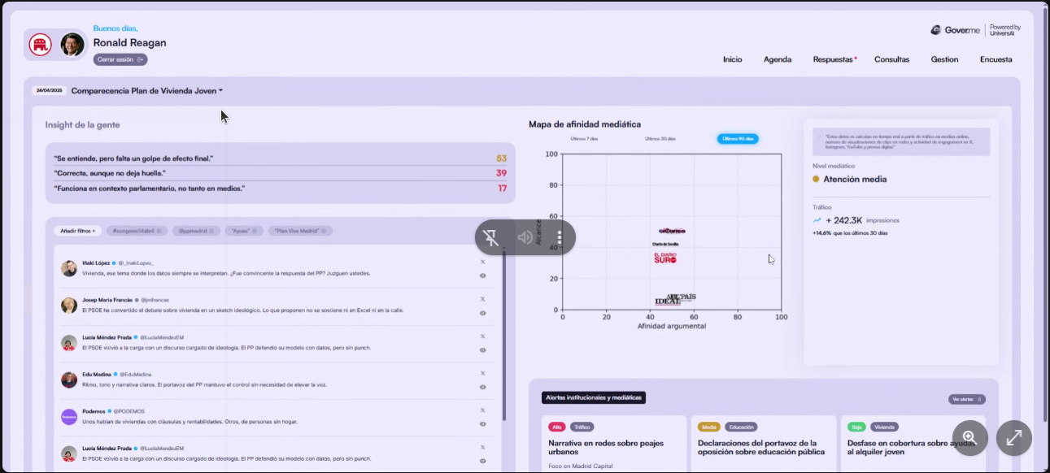

#1)
/api/message-evaluation

#2)
/api/social-monitoring
GET /api/social-monitoring
Query params:
- topics: comma-separated filter (vivienda,educacion,...). Default: all
- limit: integer. Default: 10 - since: ISO8601 datetime. Default: last 24h

# 3 endpoint
/api/media-affinity_socialnets
This endpoint is identical to: /api/media-affinity !!

https://gover2me.ngrok.app/api/media-affinity_socialnets

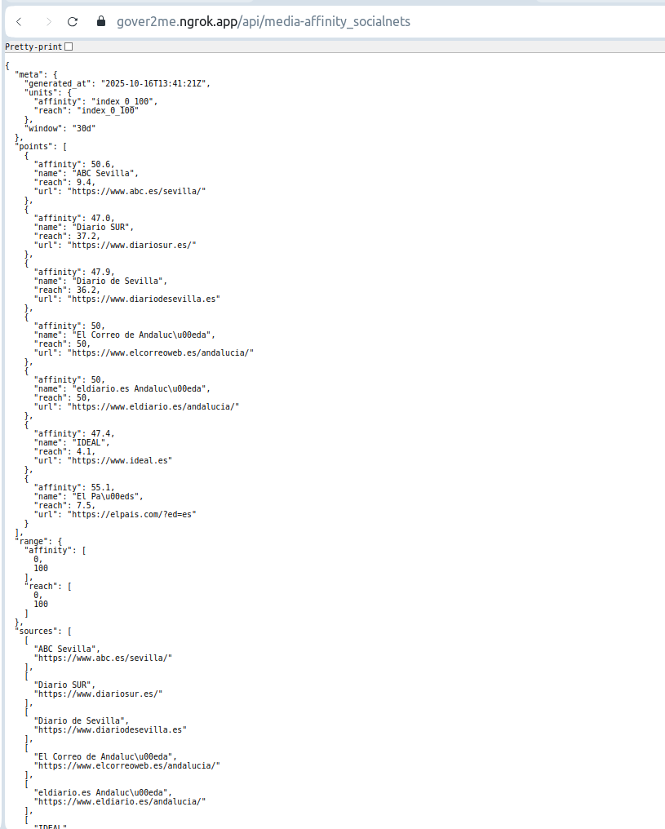
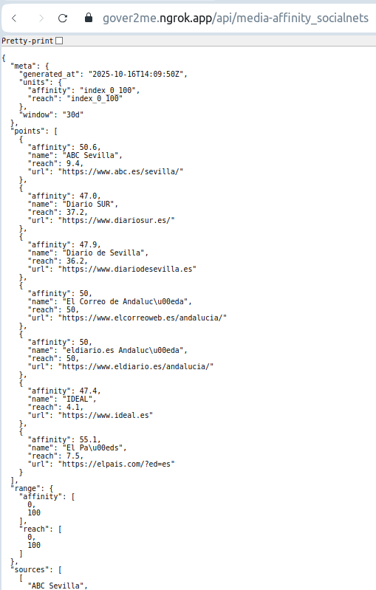

https://gover2me.ngrok.app/api/message-evaluation

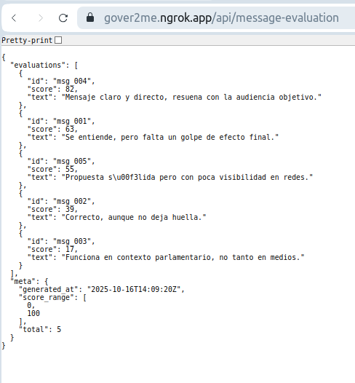
https://gover2me.ngrok.app/api/social-monitoring

